NAME - GOPI NATH SINGHA

EMAIL ID - SINGHA.GOPI33@GMAIL.COM

ASSIGNMENT NAME - Power BI Visuals ASSIGNMENT

Question 1 : Create a Card Visual to show Total Sales.

$12.64M
Sum of Sales

Question 2 : Create a Donut Chart showing Total Sales by Ship Mode and which ship mode generates the highest sales?

$0.67M (5.28%)

$1.83M (14.48%)

$2.57M (20.29%)
Ship Mode
 Standard Class  Second Class  First Class
 Same Day
Standard Class generates the highest sales

$7.58M (59.95%)

Question 3 : Create a Line Chart showing the Sales Trend over time (by Month and Year). Is there any noticeable seasonal pattern in sales?
$0.6M

$0.5M

$0.4M
Sum of Sales

$0.3M

$0.2M

$0.1M

Jan 2011 Jul 2011 Jan 2012 Jul 2012 Jan 2013 Jul 2013 Jan 2014 Jul 2014
Year

Yes! A clear pattern is visible:
Peak Sales November & December every year (holiday season)
Low Sales January & February (post-holiday drop) Mid-year rise Sales pick up again around August–September Year-on-year Overall sales are growing each year

Question 4 : Create a Bar Chart to compare Sales by Category


Technology

Furniture
Category

Office Supplies

$0M $1M $2M $3M $4M $5M
Sum of Sales

Rank | Category | Approx.
Sales
1st | Technology | ~$4.7M
2nd | Furniture | ~$4.1M

Question 5 : Create a Matrix Visual to display Sales by Month and Category and identify the month with the highest sales.
Month Furniture Office Supplies Technology Total

February | $185,359.81 | $153,504.36 | $204,875.22 $543,739.38
January | $228,566.69 | $222,235.38 | $224,331.61 $675,133.67
April | $211,210.05 | $227,602.25 | $259,748.91 $698,561.21
July | $227,108.22 | $234,934.07 | $287,339.55 $749,381.84
March | $254,891.14 | $227,700.56 | $287,909.24 $770,500.94
May | $280,688.62 | $279,817.91 | $343,505.81 $904,012.34
October | $382,255.36 | $300,781.71 | $485,147.32 $1,168,184.39
June | $411,266.10 | $372,781.29 | $485,669.36 $1,269,716.75
August | $393,218.25 | $402,527.97 | $498,086.95 | $1,293,833.17
September | $494,672.03 | $426,931.13 | $515,776.95 | $1,437,380.11
November | $502,717.07 | $468,904.46 | $579,655.81 | $1,551,277.34
December | $538,920.85 | $469,349.15 | $572,510.77 | $1,580,780.77
Total | $4,110,874.19 | $3,787,070.23 | $4,744,557.50 | $12,642,501.91

Rank Month Approx.
1st December
~$1.8M

Question 6 : Create a Decomposition Tree for Sales Breakdown.

Category ×
Technology
Sub-Category ×
Phones
Country ×
United States
Region ×
East
Segment ×

Technology
$4,744,557.50
Phones
$1,706,824.14
United States
$330,007.05
East
$100,614.98
Consumer
$51,512.04
Sum of Sales
$12,642,501.91
Furniture
$4,110,874.19
Copiers
$1,509,436.27
India
$104,627.24
West
$98,684.35
Corporate
$29,865.62

Office Supplies
$3,787,070.23
Machines
$779,060.07
Germany
$104,591.20
Central
$72,403.28
Home Office
$19,237.33

Overall Insights:
. Technology → Phones → USA → East → Consumer is the most profitable path
. US Market dominates Phone sales by a large margin over India & Germany
. Consumer segment drives the most sales in the East region

Question 7 : Create a Scatter Chart to compare Discount vs. Profit by Sub-Category. Are there any outliers where high discounts resulted in negative profit?
Discount vs Profit by Sub-Category
Sub-Category Accessories  Appliances  Art  Binders  Bookcases  Chairs  Copiers  Envelopes  Fasteners  Furnishings  Labels  Machines  Paper  Phones  Storage  Supplies  Tables

0.3M

0.2M

0.1M
Sum of Profit

0.0M

-0.1M200 400 600 800 1,000 1,200
Sum of Discount

Yes, there ARE outliers where high discounts caused negative profit

Question 8 : Use a Funnel Chart to show the number of orders by Customer Segment.
Number of Orders by Customer Segment
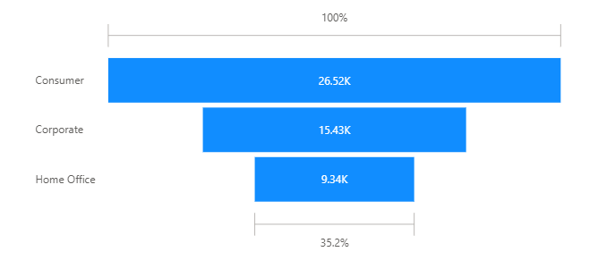

Key Insights:
- Consumer segment dominates with more than half of all orders
- Corporate is second — fewer but likely higher value orders
- Home Office has the least orders but shouldn't be ignored
- The funnel shape visually shows the drop-off between segments

Question 9 : Use a Waterfall Chart to analyze how Profit changes by Category within the countries.
Profit Changes by Category & Country
 Increase  Decrease  Total  Other
0.8M

0.6M
Sum of Profit

0.4M

0.2M

Technology France Italy United States China India Other Office
Supplies
Category

Spain Germany France Mexico Other United States Furniture

Key Insights from chart:
- Technology is the most profitable category (~$0.66M)
- Furniture has the lowest profit (~$0.27M) after country breakdowns
- United States under Furniture shows a significant profit drop
- France & Italy are strong contributors to Technology profit

Question 10 : Create a Dual-Axis Line Chart to show Total Sales and Profit Over Time (by Month).

Total Sales & Profit Over Time
 Sum of Sales  Sum of Profit
$1.6M

180K

$1.4M 160K

$1.2M 140K
Sum of Sales
Sum of Profit

$1.0M 120K

$0.8M 100K

$0.6M 80K

January February March April May June July August September October November December
Month
Key Insights from Chart:
Low Months:
- January & February → Both Sales & Profit are at their lowest
- July → Surprising sharp dip! Both lines drop suddenly
Peak Months:
- June → Unexpected mid-year spike in Profit (dark line jumps high!)
- November & December → Both Sales & Profit reach their highest

